SIMATS ENGINEERING

CSA15 – CLOUD COMPUTING AND BIG DATA ANALYTICS

ASSIGNMENT 3 – CO3
OBE-Based Evidence Principle

Design a Cloud-Based Collaborative Solution
CO3: Implement cloud-based solutions using cloud storage, web APIs, and platform services for real-world applications.

Field | Details | Field | Details
Student Name | p.udaykrishna advani | Register Number | 1925260229
Department / Section | AIML | Academic Year / Semester | 2026
Faculty Name | Dr. Latha R | Nature of Assignment | Individual
Duration | 1 Week | Total Marks | 50
Submission Date | 6/11/26 | Evaluation Date

MARK SHEET (Rubric-based evaluation)
Task | Title | Max | Awarded | Evidence / evaluation focus
1 | Accessing Cloud Services through Different Methods | 6 |  | Access-method diagram; demonstration; screenshots; comparison
2 | Cloud Platforms and Web Applications | 7 |  | Two platforms; interaction diagram; app demonstration; evaluation
3 | Web APIs for Cloud Access | 7 |  | API design; executable client; two requests; responses
4 | Cloud Security and Network Access | 7 |  | Secure-access architecture; threats; authentication; mitigations
5 | Collaboration Using Cloud-Based Services | 6 |  | Shared workspace; permissions; edits; contribution evidence
6 | Integrated Cloud Access and Collaboration Mini Investigation | 7 |  | Scenario; architecture; prototype; two user tests; evaluation
7 | Day-4 Design Challenge: Cloud-Based Collaborative Solution | 10 |  | Two independent proposals; comparison; joint design; validation; defence
 | TOTAL | 50 |  | Percentage:

OVERALL REMARKS

_______________  Student Signature | _______________  Faculty Signature | _______________  Program Director

MANDATORY SUBMISSION EVIDENCE CHECK

✓ = Present in documented answer; P = Partly present; ✗ = Missing / not satisfied
Task | Evidence expected | Status | Evaluator note
1 | Three access methods, client–network–cloud diagram, demonstration and observations |  | Access-method classification and practical access screenshots to be checked.
2 | Two-platform comparison, interaction diagram and cloud web-app demonstration |  | Platform mapping, user-action sequence and local-versus-cloud evaluation to be checked.
3 | API flow, program, two request inputs, responses and execution evidence |  | Code, actual request/response outputs and analysis to be checked.
4 | Secure-access flow, four security considerations, threat and mitigation analysis |  | Authentication, authorization and secure-communication evidence to be checked.
5 | Shared workspace, permission settings, two collaborative activities and contributions |  | Verify shared editing, user roles, permissions and contribution screenshots.
6 | Integrated scenario, architecture, prototype, two user scenarios and results |  | Verify cloud access, collaboration workflow, tests and limitations.
7 | Two initial proposals, comparison record, joint design, tests and cross-defence |  | Verify independent proposals, joint decisions, observed results and both students’ understanding.

IMPLEMENTATION EVIDENCE CHAIN
Evidence item | Status | Observation
Cloud access methods |  | Browser, mobile and API access methods explained.
Cloud platforms |  | Two cloud platforms and their applications compared.
Cloud access demonstration |  | Actual screenshots need verification.
Web API implementation |  | Program and execution outputs need verification.
Cloud security |  | Authentication, authorization and security measures explained.
Cloud collaboration |  | Shared workspace and editing evidence need verification.
Mini-project |  | Design included; practical testing needs verification.
Day-4 design challenge |  | Individual proposals, joint design and validation need verification.
Student contributions |  | Contributions of both students need confirmation.
Screenshots |  | Original execution screenshots required.

SUBMISSION CHECKLIST (Not Separately Marked)
Requirement | Status
All 7 questions answered | ☐ Yes ☐ Partly ☐ No
Cloud access methods explained | ☐ Yes ☐ Partly ☐ No
Cloud architecture diagrams included | ☐ Yes ☐ Partly ☐ No
Two cloud platforms compared | ☐ Yes ☐ Partly ☐ No
Web API program and testing completed | ☐ Yes ☐ Partly ☐ No
Cloud security explained | ☐ Yes ☐ Partly ☐ No
Cloud collaboration demonstrated | ☐ Yes ☐ Partly ☐ No
Mini-project completed and tested | ☐ Yes ☐ Partly ☐ No
Day-4 design challenge completed | ☐ Yes ☐ Partly ☐ No
Student A and B contributions recorded | ☐ Yes ☐ Partly ☐ No
Screenshots and practical evidence attached | ☐ Yes ☐ Partly ☐ No
Viva recommended | ☐ Yes ☐ No

CLOUD COMPUTING AND BIG DATA ANALYTICS
ASSIGNMENT 3 – CO3

CO3: Implement cloud-based solutions using cloud storage, web APIs, and platform services for real-world applications.

Mode: Pair Work – 2 Students per Group
Duration: 1 Week Total Marks: 50

OBE-Based Evidence Principle

The assignment requires students to demonstrate measurable evidence of:
Understand → Design → Implement → Demonstrate → Analyse → Evaluate
Both students must understand the complete assignment. Students should not simply divide questions between them. Individual responsibilities are assigned within each question so that the contribution and attainment of CO3 can be independently verified.

Q1 – Accessing Cloud Services through Different Methods 6 Marks
Shared Group Work
Together, the pair must:
- Identify different methods of accessing cloud services.
- Study browser-based/cloud console access.
- Study access through mobile applications.
- Study access through APIs.
- Identify the role of Internet/network connectivity.
- Select one suitable cloud service for demonstration.
Student A – Access Method Design
Student A must individually:
- Identify and classify at least three cloud access methods.
- Prepare a simple architecture/flow diagram showing:
Client → Network → Cloud Service
- Explain how a user accesses the selected cloud service.
- Identify the hardware/software requirements.
- Explain the role of the client and network.
- Justify which access method is most suitable for the selected application.
Student B – Practical Evidence
Student B must individually:
- Demonstrate access to a cloud service using one selected method.
- Record the steps/screenshots as evidence.
- Test the access using different devices or access methods where possible.
- Record observations such as accessibility, response, and usability.
- Identify one limitation encountered during access.
- Explain how the limitation can affect cloud usage.
Cross-Verification
Student A must be able to explain Student B's practical demonstration.
Student B must be able to explain Student A's access architecture.
Evidence Expected: Architecture diagram + screenshots/observations + comparison.

Q2 – Cloud Platforms and Web Applications 7 Marks
Shared Group Work
Together:
- Select two cloud platforms/services.
- Identify the web applications available through them.
- Study how users interact with the applications.
- Identify the cloud resources/services supporting the application.
- Prepare a comparative observation.
Student A – Platform Analysis
Student A must individually:
- Identify the major components of the selected cloud platform.
- Explain how the platform supports web applications.
- Map the user request to the cloud service.
- Explain the role of the Internet, server/cloud infrastructure and application.
- Prepare a simple interaction diagram.
Student B – Application Investigation
Student B must individually:
- Select one real-world cloud-based web application.
- Demonstrate its major functions.
- Record the sequence of user actions.
- Identify where cloud access is involved.
- Collect screenshots/evidence of the demonstration.
- Analyse the benefits of using the cloud-based application.
Joint Evaluation
Together answer:
If the same application were installed and operated only on a local computer, what limitations might users experience compared with accessing it through the cloud?
Evidence Expected: Platform/application mapping + demonstration evidence + evaluation.

Q3 – Web APIs for Cloud Access 7 Marks
Shared Group Work
Together:
- Study the concept of a Web API.
- Identify how APIs enable application-to-cloud communication.
- Select a simple publicly accessible API or cloud API.
- Develop a small program/client to send a request.
- Observe and record the response.
Student A – API Design and Understanding
Student A must individually:
- Explain the purpose of the selected API.
- Identify the request and response components.
- Represent the API communication using a flow diagram.
- Explain the role of:
  - Client
  - API request
  - Cloud/server
  - API response
- Explain how APIs enable programmatic cloud access.
Student B – Implementation and Evidence
Student B must individually:
- Implement a simple API request using Python or another suitable language.
- Execute the program.
- Record input/request and output/response.
- Test at least two different requests or inputs.
- Capture execution evidence.
- Analyse the observed results.
Joint Analysis
Together determine:
Why is API-based access useful when a large number of users/applications need to communicate with a cloud service automatically?
Evidence Expected: Program + execution screenshots + request/response evidence + analysis.

Q4 – Cloud Security and Network Access 7 Marks
Shared Group Work
Together:
- Identify security issues involved in accessing cloud services.
- Study authentication and authorization.
- Study secure network communication.
- Identify possible threats during cloud access.
- Prepare a secure cloud-access scenario.
Student B – Security Design
Student B must individually:
- Identify at least four security considerations for cloud access.
- Explain authentication and authorization.
- Explain the importance of secure communication.
- Design a secure access flow:
User → Authentication → Network → Cloud Service → Authorization → Resource
- Identify possible points of attack.
- Suggest suitable security measures.
Student A – Security Investigation
Student A must individually:
- Investigate a practical cloud-access security scenario.
- Demonstrate or document a suitable authentication mechanism where feasible.
- Compare secure and insecure access situations conceptually.
- Record observations.
- Explain how poor security practices can affect cloud users and data.
Joint Evaluation
Together answer:
If cloud access is available from anywhere through the Internet, what additional security measures are necessary compared with a local application?
Evidence Expected: Secure-access architecture + threat identification + mitigation analysis.

Q5 – Collaboration Using Cloud-Based Services 6 Marks
Shared Group Work
Together:
- Select a cloud collaboration platform/service.
- Create a shared document/folder/project space.
- Configure appropriate sharing permissions.
- Perform collaborative editing.
- Record the collaboration process.
Student A – Collaboration Design
Student A must individually:
- Identify the collaboration requirements.
- Design a suitable cloud collaboration workflow.
- Explain:
  - Sharing
  - Concurrent access
  - Version control
  - Permission management
- Identify the roles of different users.
- Justify the selected sharing permissions.
Student B – Collaborative Implementation
Student B must individually:
- Participate in the shared cloud workspace.
- Perform at least two collaborative activities.
- Record evidence of contribution.
- Demonstrate sharing/permission settings.
- Observe how changes made by users are reflected.
- Identify one collaboration issue and suggest a solution.
Cross-Understanding
Student B must explain:
How does cloud collaboration reduce the need to exchange multiple copies of the same file?
Student A must explain:
What problems can occur if incorrect sharing permissions are given?
Evidence Expected: Shared workspace + contribution evidence + permission screenshots + observations.

Q6 – Integrated Cloud Access and Collaboration Mini Investigation 7 Marks
Students must design a small real-world scenario that requires both cloud access and cloud collaboration.
Suggested Scenarios
Choose one:
- Cloud-based Student Project Management
- Online Student Attendance and Faculty Collaboration
- Cloud-Based Event Management
- Cloud-Based Assignment Submission and Evaluation
- Cloud-Based Hospital Appointment Coordination
- Cloud-Based Disaster Information Sharing
- Cloud-Based College Placement Coordination
Student A – System Design
Student A must individually:
- Define the problem.
- Identify users.
- Identify cloud access methods.
- Identify required cloud services.
- Design the system architecture.
- Explain how users access the system.
- Explain how users collaborate.
Student B – Evidence and Evaluation
Student B must individually:
- Develop a small prototype/mock-up/workflow where feasible.
- Demonstrate at least one cloud access mechanism.
- Demonstrate one collaboration mechanism.
- Record screenshots/evidence.
- Test the proposed solution using at least two user scenarios.
- Analyse the results.
- Identify limitations and possible improvements.
Joint Evaluation
Together answer:
How does combining cloud access and cloud collaboration improve the efficiency of the proposed system?

Q7 – DAY-4 DESIGN CHALLENGE

Design a Cloud-Based Collaborative Solution 10 Marks

This question must be solved collaboratively.

Neither student should independently prepare the complete solution and combine it later.

Stage 1 – Independent Design Proposal
Before discussing with each other:
Student A independently proposes:

- Problem definition
- Target users
- Cloud access method
- Required cloud services
- Collaboration mechanism
- Basic architecture
Student B independently proposes:

- Problem definition
- Target users
- Cloud access method
- Required cloud services
- Collaboration mechanism
- Basic architecture
Both initial proposals must be retained as evidence.

Stage 2 – Compare the Two Designs

Together discuss:
- Where the designs agree
- Where they differ
- Strengths and weaknesses
- Security concerns
- Accessibility
- Collaboration requirements
- Missing components
- Which ideas should be retained
Prepare a Design Comparison Record.

Stage 3 – Joint Final Design
Develop the final cloud-based solution.
The final design must identify:
- Problem
- Users
- Cloud access method
- Network requirements
- Cloud service/platform
- Web application/API requirement
- Collaboration mechanism
- Authentication/security
- Data/resource sharing
- Complete system workflow
Prepare an architecture such as:

Users → Client → Internet/Network → Cloud Platform → Application/API → Shared Resources

Stage 4 – Validation

Student A – Technical Validation

Student A must:
- Explain the selected cloud access method.
- Justify the platform/service selection.
- Explain the system architecture.
- Explain how API/web access is used, if applicable.
- Analyse the suitability of the design.

Student B – Experimental Validation

Student B must:
- Design test cases.
- Demonstrate the solution/workflow.
- Test different users/access conditions.
- Record observations.
- Present screenshots or other evidence.
- Compare expected and observed behaviour.

Stage 5 – Cross-Defence

Student A must explain:
What experimental evidence supports the group's cloud design?

Student B must explain:
Why was the selected cloud access and collaboration approach chosen?

Stage 6 – Joint Evaluation

Together determine:
- Benefits of the proposed cloud solution
- Access-related limitations
- Collaboration benefits
- Security risks
- Scalability considerations
- Possible improvements
- Situations where the proposed approach may not be appropriate
Final Question

What characteristics should a system designer consider before selecting cloud-based access and collaboration for a real-world application?

CONTRIBUTION RECORD

Each pair must include the following table at the end of the submission.
Question | Student A –  Primary Contribution | Student B –  Primary Contribution | Joint Work
Q1
Q2
Q3
Q4
Q5
Q6
Q7
The contribution record must reflect the actual work completed.
Primary contribution does not mean exclusive responsibility. Both students are accountable for the complete assignment.

INDIVIDUAL VERIFICATION – OBE EVIDENCE
Faculty may select any question or component for individual verification.
Each student must be able to:
- Explain the cloud access method.
- Explain the role of client, network and cloud service.
- Explain web application/API access.
- Explain security considerations.
- Demonstrate cloud collaboration.
- Interpret experimental evidence.
- Justify design decisions.
- Respond to a modified requirement or scenario.
A student should not answer:
“My partner did this section.”
Understanding of the complete submitted work is mandatory.

RECOMMENDED FACULTY VERIFICATION MODEL – VIVA
For each student, conduct a brief 4–5 minute verification.
Question 1 – Primary Responsibility
Ask one technical question from the component for which the student had primary responsibility.
Question 2 – Partner's Responsibility
Ask one question from a component primarily completed by the partner.
Question 3 – Transfer Question
Modify a condition and ask the student to reason about the consequence.
Examples:
“If Internet connectivity becomes unreliable, how would it affect cloud access?”
“If a shared cloud document is given editing permission to everyone, what problems could occur?”
“If the API becomes unavailable, how would your application behave?”
“If a user is authenticated but does not have permission to access a resource, what should happen?”
This provides individual evidence of CO3 attainment without requiring two completely separate assignments.

OBE Evidence Mapping
CO3 Component | Assignment Evidence
Build methods to access cloud | Q1, Q2, Q3
Access through platforms/web applications | Q2
Programmatic/API-based access | Q3
Secure cloud access | Q4
Collaboration within cloud | Q5
Apply cloud access + collaboration | Q6
Design and evaluate a cloud solution | Q7
Individual attainment | Viva + contribution record
Practical evidence | Screenshots, programs, observations, test results
Higher-order learning | Design, analysis, evaluation and transfer questions

ANSWERS – ASSIGNMENT 3 (CO3)
CSA15 – Cloud Computing and Big Data Analytics
Group: Student A and Student B (pair work)
Note: Diagrams, tables, designs and code below are complete. Items in [square brackets] (screenshots, your own observed output) must come from your own run, because original execution evidence is required.

Q1 – Accessing Cloud Services through Different Methods (6 Marks)
Shared Group Work
Selected cloud service for demonstration: Google Drive (cloud storage). Cloud services are reached over the Internet, so the user needs a client device, a network connection and credentials. Three main access methods are used: (1) browser / cloud console, (2) mobile application, (3) API (programmatic access). Network connectivity carries every request from the client to the provider's data centre and returns the response.
Student A – Access Method Design
Classification of cloud access methods
Method | How it works | Typical user | Example
Browser / cloud console | User opens a URL, logs in and uses the provider's web interface over HTTPS | Students, office users, administrators | drive.google.com, AWS / Azure console
Mobile application | Installed app talks to the cloud service in the background; supports push notification and offline caching | Users on the move | Google Drive app (Android / iOS)
API access | A program sends HTTP requests (REST) with a token and receives JSON data | Developers, automated systems | Google Drive REST API

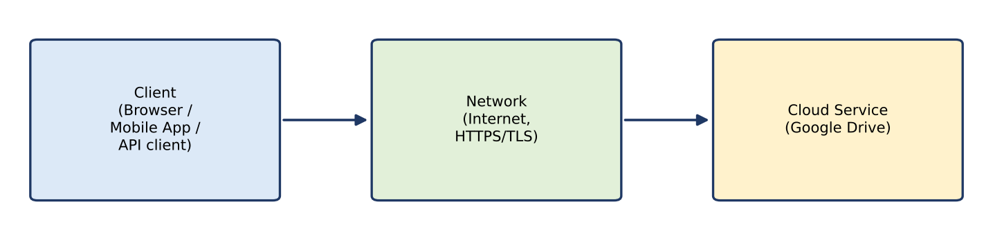
Figure 1: Client → Network → Cloud Service
How a user accesses the selected service: the user opens the browser or app → enters credentials (authentication) → the request travels through the Internet using HTTPS → the cloud service verifies the user and returns the files/folders → the client displays them.
Hardware / software requirements
• Hardware: laptop, desktop, tablet or smartphone; network adapter (Wi-Fi / mobile data).
• Software: modern web browser, or the Drive mobile app; for API access a programming environment (Python) with the requests library.
• Account and credentials (Google account), Internet connection.
Role of client and network: the client creates the request, presents the interface and holds credentials/tokens; the network (Internet) transports the request securely (TLS) and its speed and reliability decide response time. The cloud service stores data, processes the request and enforces access rights.
Most suitable method: for a storage service used by students and faculty, browser access is most suitable, because it needs no installation, works on any device and gives full functions. Mobile app is best for quick on-the-go use, and API access is best for automation.
Student B – Practical Evidence
Demonstration (method used: browser access to Google Drive). Steps:
• Open the browser and go to drive.google.com.
• Log in with the Google account (enter user ID and password / verification).
• Click New → File upload and upload a sample file; create a new folder.
• Open the file to confirm it is stored in the cloud; log out.
Screenshot placeholder
[Insert screenshots: login page, Drive home, file upload, uploaded file]

Testing on different devices / methods
Device / method | Access result | Observation (record your own)
Laptop – Chrome browser | Successful | Full features, fast response
Smartphone – Drive app | Successful | Convenient, touch interface, smaller screen
Smartphone – mobile browser | Successful | Works, but some functions are limited

Limitation encountered: dependence on Internet connectivity – on a slow or lost connection, uploads were slow or failed and files could not be opened (unless offline mode was enabled in advance).
Effect on cloud usage: users cannot work or retrieve data during an outage, productivity falls, and uploads may be incomplete. Remedies are offline mode, a backup network and saving work frequently.
Cross-verification: Student A can explain B's demonstration (steps and screenshots) and Student B can explain A's Client → Network → Cloud architecture.
Evidence: Architecture diagram (Figure 1) + screenshots/observations + comparison table above.

Q2 – Cloud Platforms and Web Applications (7 Marks)
Shared Group Work
Two cloud platforms selected: Google Cloud Platform / Google Workspace and Microsoft Azure / Microsoft 365.
Aspect | Google Cloud / Workspace | Microsoft Azure / Microsoft 365
Web applications | Google Docs, Sheets, Gmail, Meet, Drive | Word / Excel / Outlook Online, Teams, OneDrive
Compute / hosting | Compute Engine, App Engine, Cloud Run | Virtual Machines, App Service, Functions
Storage | Cloud Storage, Google Drive | Blob Storage, OneDrive, SharePoint
Database | Cloud SQL, Firestore, BigQuery | Azure SQL, Cosmos DB, Synapse
User access | Browser, mobile app, REST APIs | Browser, mobile app, REST APIs / Graph API
User interaction | Open URL → sign in → edit online; changes auto-saved | Open URL → sign in → edit online; changes auto-saved

Both platforms provide a web application layer on top of cloud infrastructure (compute, storage, database) and are accessed via a browser.
Student A – Platform Analysis (Google Cloud / Workspace)
• Major components: compute (virtual machines / app hosting), storage (Cloud Storage, Drive), databases, networking and load balancing, identity and access management, and management console/APIs.
• How the platform supports web applications: the application runs on cloud servers; data is kept in cloud storage/databases; load balancers distribute many users; the platform scales resources automatically and keeps copies for reliability.
• User request mapping: browser request → Internet → load balancer / web server → application logic → storage / database → response to browser.
• Roles: Internet = carries requests/responses; server/cloud infrastructure = processing and storage; application = business logic and user interface.
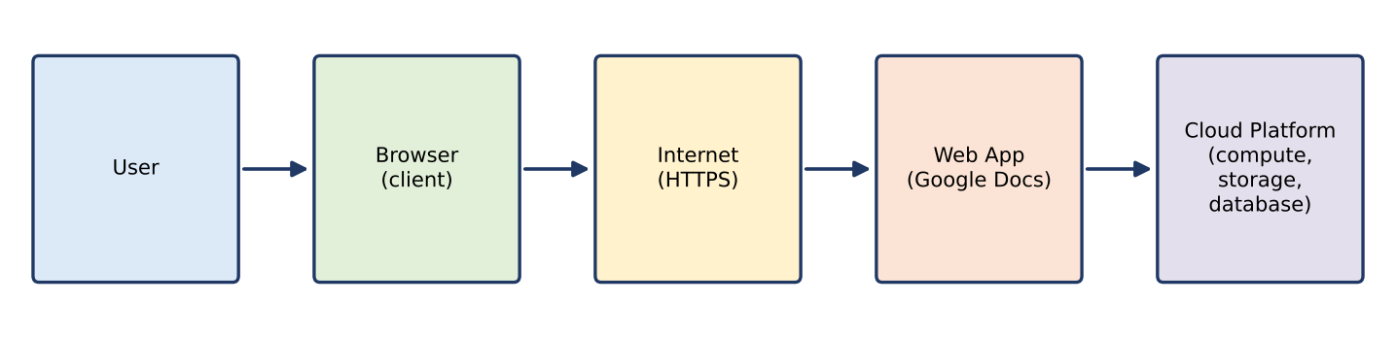
Figure 2: User request interaction diagram
Student B – Application Investigation
Selected application: Google Docs (cloud-based word processor).
Major functions demonstrated: create a document, edit and format text, share with other users, comment, view version history, download as PDF/Word.
Sequence of user actions: open browser → sign in → open Google Docs → create new document → type and format → share with a second user → second user edits → check version history → download/export.
Where cloud access is involved: sign-in (authentication), auto-saving every change to cloud storage, opening the same file from another device, sharing links and real-time updates to other users.
Screenshot placeholder
[Insert screenshots: Docs home, new document, share dialog, version history]

Benefits of the cloud application: no installation; access from any device; automatic saving and backup; real-time collaboration; automatic updates; no loss of work if the local device fails; cost saving.
Joint Evaluation
If the same application were installed and operated only on a local computer, what limitations might users experience compared with the cloud?
• Access only from that computer; no anywhere/any-device access.
• Users must install, license and update the software manually.
• Data is on one disk – risk of loss on hardware failure unless backed up manually.
• Sharing requires e-mailing multiple copies, causing version confusion; no real-time co-editing.
• Limited storage and processing power of the local machine; poor scalability.
• Higher maintenance and hardware cost for the user.
Evidence: platform/application mapping (table + Figure 2) + demonstration screenshots + evaluation.

Q3 – Web APIs for Cloud Access (7 Marks)
Shared Group Work
A Web API is an interface that lets one program talk to a service over HTTP. Cloud providers expose their services (storage, compute, data) as REST APIs, so applications can send a request and receive a response (usually JSON) without a human using a browser. Selected API: JSONPlaceholder – a free public REST API (https://jsonplaceholder.typicode.com) that needs no key.
Student A – API Design and Understanding
Purpose of the API: it provides sample cloud-hosted data (posts, users) over REST so that clients can practise sending requests and processing responses.
Request components: HTTP method (GET), URL/endpoint (e.g. /posts/1), headers (e.g. Accept: application/json), optional query parameters, and body (for POST). Response components: status code (200 OK, 404 Not Found), headers, and body (JSON data).
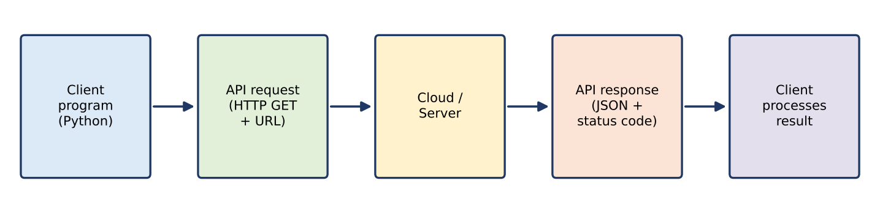
Figure 3: API communication flow
• Client: the program/application that sends the request.
• API request: the formatted HTTP message identifying the resource and action.
• Cloud/server: receives the request, authenticates if needed, processes it and fetches the data.
• API response: the returned status code and data that the client uses.
How APIs enable programmatic cloud access: APIs give a standard, machine-readable way to use cloud resources, so software can automatically upload files, read data or start services without manual browser use.
Student B – Implementation and Evidence
Python program (two different requests plus an error test):
import requests

BASE = "https://jsonplaceholder.typicode.com"

def call(endpoint):
url = BASE + endpoint
r = requests.get(url, headers={"Accept": "application/json"}, timeout=10)
print("REQUEST :", "GET", url)
print("STATUS :", r.status_code)
print("RESPONSE:", r.text[:300])
print("-" * 60)

call("/posts/1") # Request 1
call("/users/1") # Request 2
call("/posts/9999") # Extra test: non-existent resource

Requests and expected responses (documented behaviour of this API; paste your actual run output as evidence):
Request | Input | Status | Response (key fields)
1 | GET /posts/1 | 200 OK | JSON object: userId 1, id 1, title "sunt aut facere repellat provident occaecati excepturi optio reprehenderit", body text
2 | GET /users/1 | 200 OK | JSON object: id 1, name "Leanne Graham", username "Bret", email, address, company
3 (extra) | GET /posts/9999 | 404 Not Found | Empty JSON object {} – resource does not exist

Screenshot placeholder
[Insert screenshot of the program execution showing the request and response output]

Analysis of results: the same client code worked for different endpoints by changing only the URL; a 200 status shows a successful request and a returned JSON body, while 404 shows the cloud server answering correctly for a missing resource. This proves that the client can communicate with a remote cloud service automatically and that the response must be checked (status code) before use.
Joint Analysis
Why is API-based access useful when a large number of users/applications need to communicate with a cloud service automatically?
• Automation: programs can send thousands of requests without human interaction.
• Standard format (HTTP/JSON) lets different languages, devices and applications interoperate.
• Scalability: the cloud handles many simultaneous requests using load balancing.
• Integration: one service can be reused by many applications (web, mobile, IoT).
• Control: authentication keys/tokens, rate limiting and monitoring manage usage and security.
• Faster and cheaper than manual access; consistent results.
Evidence: program + execution screenshots + request/response record + analysis.

Q4 – Cloud Security and Network Access (7 Marks)
Shared Group Work
Because cloud services are reached over the public Internet, the main issues are unauthorised access, data theft, data leakage, insecure communication and misconfiguration. Authentication proves who the user is; authorization decides what that user may do; secure communication (TLS/HTTPS) protects data in transit.
Student B – Security Design
Security considerations (at least four):
• Authentication – strong passwords and multi-factor authentication (MFA).
• Authorization / access control – role-based access and least privilege.
• Encryption – HTTPS/TLS for data in transit; encryption of stored data (at rest).
• Data privacy and compliance – protect personal data, follow provider and legal policies.
• Monitoring and logging – audit logs and alerts for unusual logins.
• Backup and recovery – protection against loss or ransomware.
Authentication vs authorization: authentication = “Who are you?” (password, OTP, biometric). Authorization = “What are you allowed to do?” (view, edit, delete). A user can be authenticated but still not authorized for a resource.
Importance of secure communication: without TLS, data and passwords can be read or changed by attackers on the network (man-in-the-middle). HTTPS gives confidentiality, integrity and server identity.
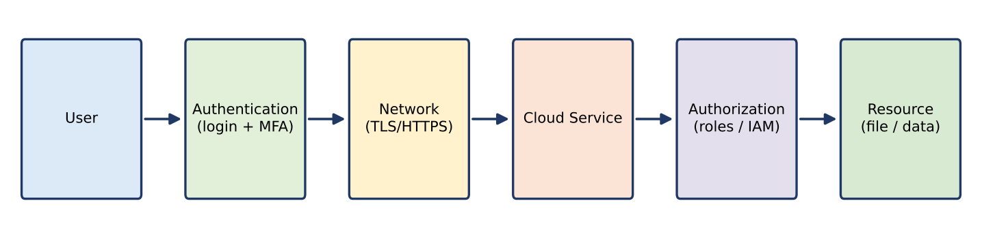
Figure 4: Secure access flow
Points of attack and measures
Attack point | Threat | Security measure
User / credentials | Phishing, weak or stolen passwords | MFA, strong password policy, user awareness
Network | Eavesdropping, man-in-the-middle | HTTPS/TLS, VPN on untrusted networks
Cloud service | DDoS, brute-force login | Firewall, rate limiting, account lock-out
Authorization | Over-permissioned users, misconfigured sharing | Least privilege, role-based access, periodic review
API | Leaked keys/tokens | Token expiry, key rotation, store keys securely
Resource / data | Data leakage, loss, ransomware | Encryption at rest, backup, audit logs

Student A – Security Investigation
Scenario investigated: a student accesses a shared Google Drive folder from a public Wi-Fi hotspot.
Authentication mechanism documented: Google account login with 2-step verification – after the password, a one-time code/prompt on the registered phone is required. [Insert screenshots of the sign-in and 2-step verification setup.]
Secure vs insecure access (conceptual)
Aspect | Secure access | Insecure access
Connection | HTTPS (padlock), trusted network or VPN | Plain HTTP / unknown open Wi-Fi
Login | Strong password + MFA | Weak or reused password, no MFA
Permissions | Only needed users, role-based | “Anyone with link can edit”
Result | Data protected, activity traceable | Account takeover, data leak

Effect of poor security practices: stolen accounts, exposure or deletion of personal and project data, identity misuse, financial or reputation loss, and legal consequences for the organisation.
Joint Evaluation
If cloud access is available from anywhere through the Internet, what additional security measures are necessary compared with a local application?
• Mandatory strong authentication (MFA) because the service is exposed to the whole Internet.
• Encrypted communication (TLS) and VPN/secure network use; encryption of stored data.
• Fine-grained authorization and regular permission review.
• Firewalls, DDoS protection and rate limiting at the provider side.
• Continuous monitoring, logging and alerts for unusual locations/devices.
• Secure API key/token management, backups and incident-response plan.
Evidence: secure-access architecture (Figure 4) + threat identification + mitigation analysis.

Q5 – Collaboration Using Cloud-Based Services (6 Marks)
Shared Group Work
Platform selected: Google Drive with Google Docs. A shared folder “CO3_Group_Project” and a shared document “Cloud_Access_Report” were created. Permissions: Student A – Owner/Editor; Student B – Editor; Faculty – Commenter (view and comment only). The pair then edited the document together and recorded the process with screenshots.
Screenshot placeholder
[Insert screenshots: shared folder, Share dialog showing roles, document with both users' edits]

Student A – Collaboration Design
Requirements: shared storage, controlled access, simultaneous editing, change tracking, comments/feedback, access from any device.
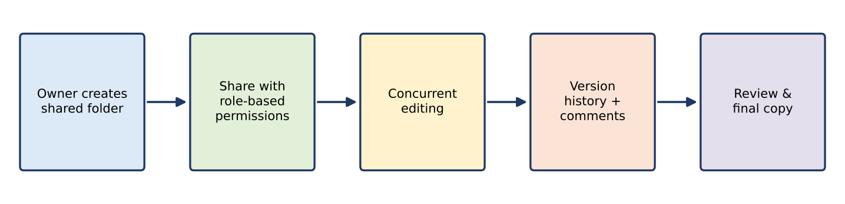
Figure 5: Cloud collaboration workflow
• Sharing: owner shares a folder/document by e-mail invitation or link with a chosen role.
• Concurrent access: several users edit the same online file at the same time and see changes almost instantly; cursor colours show who is editing.
• Version control: version history records who changed what and when and allows restoring an earlier version.
• Permission management: roles Viewer / Commenter / Editor / Owner restrict actions; access can be removed anytime.
User | Role | Permission given | Justification
Student A | Owner / Editor | Full control, manage sharing | Responsible for the workspace
Student B | Editor | Edit, comment | Contributes content
Faculty | Commenter | View and comment only | Reviews without altering the work
Others | No access / Viewer | Restricted | Principle of least privilege

Student B – Collaborative Implementation
• Activity 1: co-edited the shared document – each user wrote different sections at the same time.
• Activity 2: added comments and suggestions, and resolved them; also uploaded a file to the shared folder.
• Evidence of contribution: version history and comment screenshots showing each user's name and time.
• Permissions demonstrated: Share dialog showing Editor, Commenter and Viewer roles.
• Reflection of changes: edits made by one user appeared on the other user's screen almost immediately.
Issue and solution: two users edited the same paragraph and one change overwrote the other. Solution: assign separate sections, use “Suggesting” mode, and restore from version history when needed.
Cross-Understanding
Student B – How does cloud collaboration reduce the need to exchange multiple copies of the same file? All users work on one single shared file stored in the cloud; changes are saved to the same master copy, so there is no e-mailing of copies, no confusion about the latest version, and version history keeps older states.
Student A – What problems can occur if incorrect sharing permissions are given? Unauthorised people may view confidential data (data leak); too many editors may accidentally edit or delete content; a viewer-level user could not contribute; ownership issues and loss of data integrity; difficulty tracing responsibility.
Evidence: shared workspace + contribution evidence + permission screenshots + observations.

Q6 – Integrated Cloud Access and Collaboration Mini Investigation (7 Marks)
Chosen scenario: Cloud-Based Assignment Submission and Evaluation.
Student A – System Design
• Problem: paper/e-mail assignment submission causes lost files, late or duplicate submissions, delay in evaluation and no common record of marks and feedback.
• Users: students (submit), faculty (review, give marks and feedback), department coordinator (monitor).
• Cloud access methods: browser access to Google Drive/Classroom on laptops; mobile app access for students; optional API access for report generation.
• Cloud services required: cloud storage (Drive), online documents (Docs/Sheets), form for submission (Forms), identity management (Google accounts), notification (e-mail).
• How users access: every user signs in with an institutional account through browser or app over HTTPS.
• How users collaborate: a shared folder per class; students upload work with edit rights only to their own folder; faculty comment in the document and record marks in a shared marks sheet; students see feedback and can resubmit before the deadline.
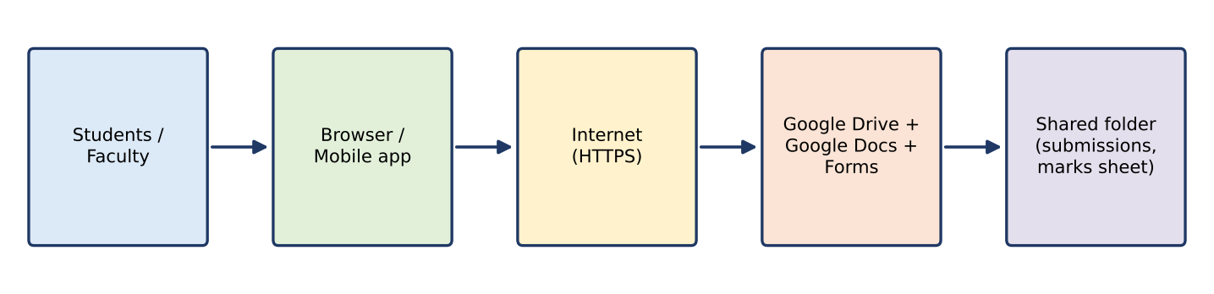
Figure 6: Architecture of the cloud assignment system
Student B – Evidence and Evaluation
• Prototype: shared Drive folder structure (Class → Assignment → Student folders), a submission form and a marks Google Sheet.
• Cloud access mechanism demonstrated: login through browser and mobile app and upload of an assignment file.
• Collaboration mechanism demonstrated: faculty comments on the student's document and updates marks in the shared sheet.
Screenshot placeholder
[Insert screenshots: folder structure, upload by student, faculty comment, marks sheet]

Testing with two user scenarios
Scenario | Action | Expected result | Observed result
1 – Student submission | Student logs in on mobile/browser and uploads file to own folder | File stored, time stamp recorded, faculty can see it | [record]
2 – Faculty evaluation | Faculty opens submission, adds comments, enters marks in sheet | Student sees comments and marks; other students cannot see them | [record]

Analysis of results: the workflow removes e-mail exchanges, keeps one copy of each submission, gives instant feedback and tracks time and version. Role-based sharing kept other students' work private.
Limitations: needs Internet access; depends on the provider's availability; misconfigured permissions may expose work; limited automation of plagiarism checks and grading.
Possible improvements: MFA, automatic deadline reminders through API/scripts, offline drafts, backups, and integration with the college LMS.
Joint Evaluation
How does combining cloud access and cloud collaboration improve the efficiency of the proposed system? Cloud access makes the system available anytime from any device, while collaboration lets students and faculty work on the same shared files with controlled permissions. Together they remove manual file transfer, reduce delay and duplication, give instant feedback and a single version of records, and save time and cost for all users.

Q7 – Day-4 Design Challenge: Cloud-Based Collaborative Solution (10 Marks)
Stage 1 – Independent Design Proposals (retained as evidence)
Item | Student A proposal | Student B proposal
Problem | Student project teams lack one place to share files, tasks and progress | Event committees struggle with scattered files and last-minute updates
Target users | Students, project guide, coordinator | Event coordinators, volunteers, faculty advisor
Cloud access method | Browser access (laptop / lab PC) | Mobile app access
Required cloud services | Cloud storage, online docs, task sheet, identity management | Cloud storage, shared calendar, forms, messaging
Collaboration mechanism | Shared folder with comments and version history | Shared calendar/task list with real-time updates
Basic architecture | User → Browser → Internet → Google Workspace → Shared project folder | User → Mobile app → Internet → Cloud calendar/storage → Shared event data

Stage 2 – Design Comparison Record
Point | Comparison
Where designs agree | Both use cloud storage, Internet access, shared online files, account-based login and role-based sharing.
Where they differ | A: browser-based, document/project focus. B: mobile-first, calendar/time focus.
Strengths / weaknesses | A: full-featured editing but less convenient on phones. B: convenient and real-time notifications but limited editing on small screens.
Security concerns | Both need MFA, least-privilege roles and encrypted communication; B needs protection of mobile devices.
Accessibility | Combine browser + mobile so every user can access from any device.
Collaboration requirements | Concurrent editing, comments, version history (A) plus shared calendar and notifications (B).
Missing components | A: notifications and mobile use. B: version control and document storage structure. Both: backup and API integration.
Ideas retained | Browser + mobile access, shared folders with version history, shared task calendar, MFA, role-based permissions, notification API.

Stage 3 – Joint Final Design
Final solution: Cloud-Based Student Project Collaboration System.
Design element | Decision
Problem | Project teams need a secure common place to store files, assign tasks, collaborate and track progress.
Users | Students, project guide, coordinator.
Cloud access method | Browser (primary) and mobile app (secondary); API for automatic notifications.
Network requirements | Internet/Wi-Fi with HTTPS; minimum stable broadband/mobile data; offline mode for drafts.
Cloud service / platform | Google Workspace (Drive, Docs, Sheets, Calendar) on Google Cloud.
Web application / API | Web apps: Docs, Sheets, Calendar; REST API (Drive/Calendar API) for reminders and status reports.
Collaboration mechanism | Team shared folders, concurrent editing, comments, version history, shared task sheet and calendar.
Authentication / security | Institutional login with MFA; role-based access (Owner, Editor, Commenter, Viewer); TLS; audit logs; backup.
Data / resource sharing | Project folders per team; guide has Commenter role; coordinator has Viewer role; external sharing disabled.

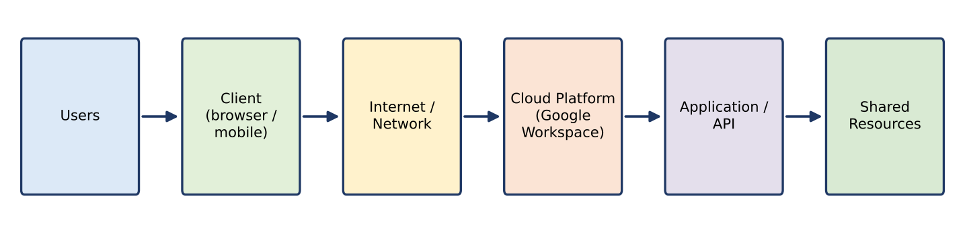
Figure 7: Joint system architecture
Complete workflow: user signs in with MFA → opens team folder (browser/mobile) → edits shared documents and updates task sheet → API sends reminders → guide reviews and comments → version history and logs record all changes → coordinator monitors progress.
Stage 4 – Validation
Student A – Technical Validation
• Access method: browser is primary because it needs no installation and supports full editing; mobile gives convenience and notifications.
• Platform selection: Google Workspace provides storage, online documents, real-time collaboration, version control and APIs in one integrated service, with low cost for education.
• Architecture: Users → Client → Internet → Cloud Platform → Application/API → Shared Resources (Figure 7).
• API/web use: web apps for daily work; Calendar/Drive API to send automatic reminders and generate progress reports.
• Suitability: meets access-anywhere, collaboration, security and scalability needs for student teams; limits are Internet dependence and provider dependence.
Student B – Experimental Validation
Test case | Condition | Expected behaviour | Observed
TC1 | Editor edits shared doc from browser | Change saved and visible to team | [record]
TC2 | Second user opens the file from mobile at the same time | Real-time update shown on both devices | [record]
TC3 | Commenter (guide) tries to edit | Edit blocked, comment allowed | [record]
TC4 | Outsider (not shared) opens link | Access denied | [record]
TC5 | Internet disconnected | Online access fails; offline draft available if enabled; sync after reconnect | [record]
TC6 | Restore previous version | Older version restored from history | [record]

Screenshot placeholder
[Insert screenshots of test cases TC1–TC6 and comparison of expected vs observed behaviour]

Stage 5 – Cross-Defence
Student A – What experimental evidence supports the group's cloud design? Test results show that shared files updated for all users on different devices (TC1–TC2), permissions blocked unauthorised actions (TC3–TC4), version history restored earlier content (TC6), and behaviour during network loss was identified (TC5). Matching expected and observed behaviour, with screenshots, confirms the design works.
Student B – Why was the selected cloud access and collaboration approach chosen? Browser access works on any device without installation, mobile access adds convenience, and Google Workspace provides built-in real-time collaboration, version control, permission roles and MFA at low cost. This removes multiple file copies and supports team progress tracking, which was the main problem.
Stage 6 – Joint Evaluation
Aspect | Evaluation
Benefits | Anywhere access, one master copy, real-time teamwork, automatic backup, low cost, no installation.
Access-related limitations | Needs Internet; slow networks affect performance; mobile screens limit complex editing.
Collaboration benefits | Concurrent editing, comments, version history, clear roles, faster feedback.
Security risks | Account compromise, wrong sharing permissions, phishing, data leak, provider outage.
Scalability | Can grow from a few teams to the whole department without new hardware; storage quotas and licence cost must be planned.
Possible improvements | Enforce MFA, periodic permission audit, scheduled backups, API automation, LMS integration, offline mode training.
Not appropriate when | Highly confidential/regulated data with strict on-premises rules, areas with unreliable Internet, or real-time heavy computing needs.

Final Question
What characteristics should a system designer consider before selecting cloud-based access and collaboration for a real-world application?
• Connectivity: availability and reliability of Internet for all users.
• Security and privacy: sensitivity of data, authentication, authorization, encryption, legal/compliance rules.
• Users and devices: who the users are, their skills and the devices they use (accessibility).
• Collaboration needs: concurrent editing, version control, roles and permissions.
• Scalability and performance: number of users, workload growth, response time.
• Cost: subscription, storage and data-transfer charges versus local infrastructure.
• Reliability and vendor dependence: service availability (SLA), backup, data portability and risk of vendor lock-in.
• Integration: availability of APIs and compatibility with existing systems.
• Management: monitoring, support, training and recovery plan.

CONTRIBUTION RECORD (completed)
Question | Student A – Primary Contribution | Student B – Primary Contribution | Joint Work
Q1 | Access methods, architecture diagram, requirements, justification | Practical access demonstration, screenshots, device testing, limitation | Selection of service; cross-explanation
Q2 | Platform components, request mapping, interaction diagram | Application demonstration, action sequence, screenshots, benefits | Platform comparison; local-vs-cloud evaluation
Q3 | API purpose, request/response components, flow diagram | Python program, execution, two requests, analysis | API selection; analysis of API usefulness
Q4 | Security investigation, authentication documentation, secure vs insecure comparison | Security considerations, secure access flow, attack points, measures | Threat identification; additional measures
Q5 | Collaboration design, roles, permission justification | Collaborative activities, contribution evidence, issue and solution | Shared workspace creation; cross-answers
Q6 | Problem, users, services, architecture | Prototype, tests with two scenarios, results, limitations | Scenario selection; efficiency evaluation
Q7 | Initial proposal A, technical validation | Initial proposal B, test cases and experimental validation | Comparison record, final design, cross-defence, joint evaluation

Both students are accountable for the complete assignment. Edit the table above to reflect the work you actually completed.

VIVA – TRANSFER QUESTION ANSWERS
• If Internet connectivity becomes unreliable, how would it affect cloud access? Requests time out, uploads/downloads fail or slow, real-time collaboration stops; offline mode, retry logic and local drafts that sync later reduce the impact.
• If a shared cloud document is given editing permission to everyone, what problems could occur? Accidental or malicious edits/deletion, data leak, conflicting changes and no accountability; use role-based sharing and version history.
• If the API becomes unavailable, how would your application behave? The request would return an error or time out; the application should check the status code, retry with delay, show a clear message and use cached data or a fallback.
• If a user is authenticated but does not have permission to access a resource, what should happen? The request is denied with an authorization error (e.g. 403 Forbidden) and the attempt is logged; authentication success does not grant access.

